**AuthController – UpdatePassword**

**Create a new DTO -> PasswordDTO.java**

package org.studyeasy.SpringRestdemo.payload.auth;

import io.swagger.v3.oas.annotations.media.Schema;

import io.swagger.v3.oas.annotations.media.Schema.RequiredMode;

import jakarta.validation.constraints.Size;

import lombok.Getter;

import lombok.NoArgsConstructor;

import lombok.Setter;

@Getter

@Setter

@NoArgsConstructor

public class PasswordDTO {

    @Size(min = 6, max = 20)

    @Schema(description = "Password", example = "Password", requiredMode = RequiredMode.REQUIRED, maxLength = 20, minLength = 6)

    private String password;

}

**Updated AccountViewDTO.java**

package org.studyeasy.SpringRestdemo.payload.auth;

import jakarta.persistence.GeneratedValue;

import jakarta.persistence.GenerationType;

import jakarta.persistence.Id;

import lombok.AllArgsConstructor;

import lombok.Getter;

import lombok.Setter;

@Setter

@Getter

@AllArgsConstructor

public class AccountViewDTO {

    @Id

    @GeneratedValue(strategy = GenerationType.SEQUENCE)

    private long id;

    private String email;

    private String authorities;



}

**API to update password creation: - In AuthController.java, add below code**

@PutMapping(value = "/profile/update-password", produces = "application/json", consumes = "application/json")

@Operation(summary = "Update Profile")

@ApiResponse(responseCode = "200", description = "List of users")

@ApiResponse(responseCode = "401", description = "Token missing")

@ApiResponse(responseCode = "403", description = "Token error")

@SecurityRequirement(name = "studyeasy-demo-api")

public AccountViewDTO update_password(@Valid @RequestBody PasswordDTO passwordDTO, Authentication authentication){

        String email = authentication.getName();

        Optional<Account> optionalAccount = accountService.findByEmail(email);

        if(optionalAccount.isPresent()){

            Account account = optionalAccount.get();

            account.setPassword(passwordDTO.getPassword());

            accountService.save(account);

            AccountViewDTO accountViewDTO = new AccountViewDTO(account.getId(), account.getEmail(), account.getAuthorities());

            return accountViewDTO;

        }

        return null;

    }

**Output**

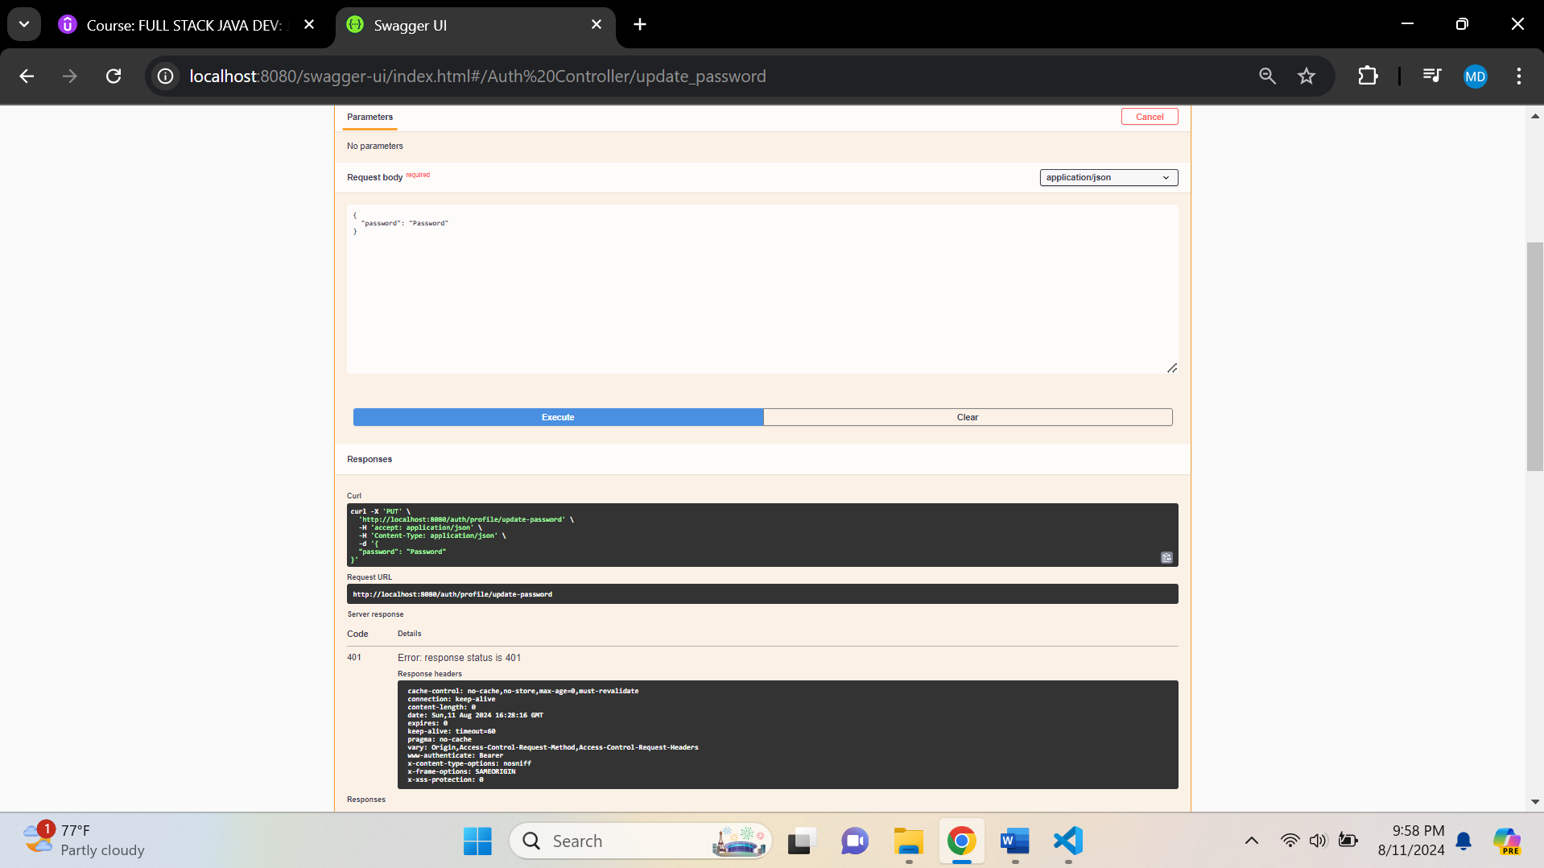

**Generate a token – User**

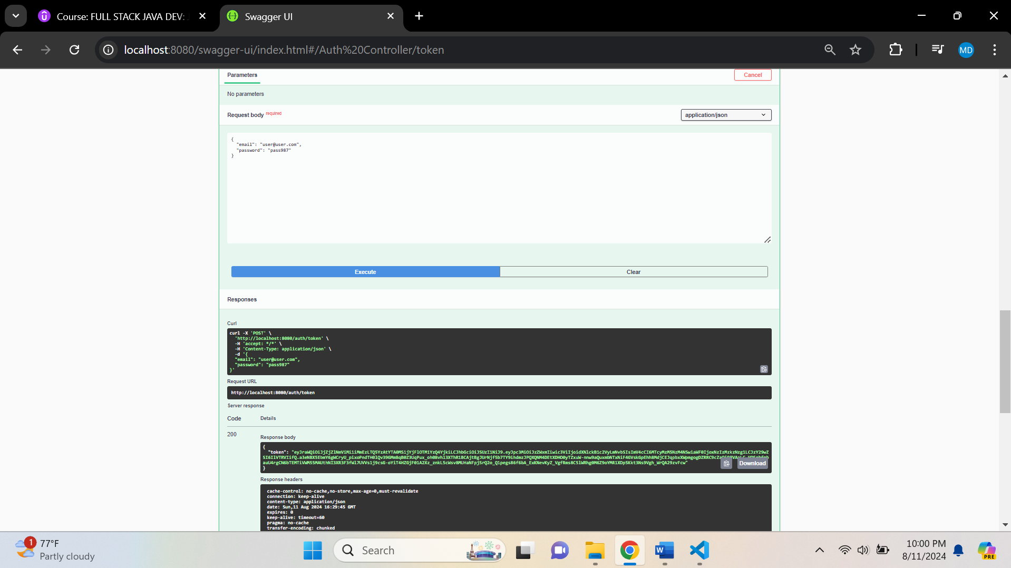

**Authorize**

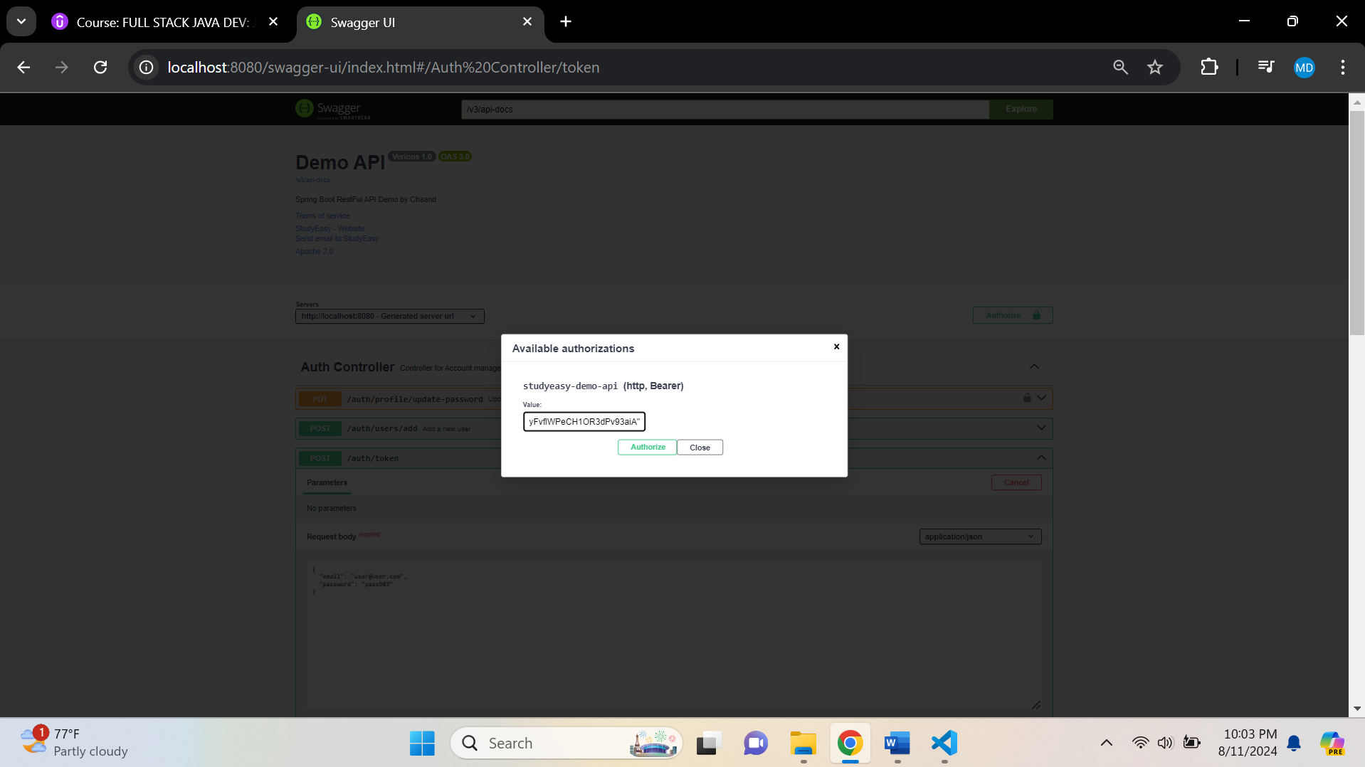

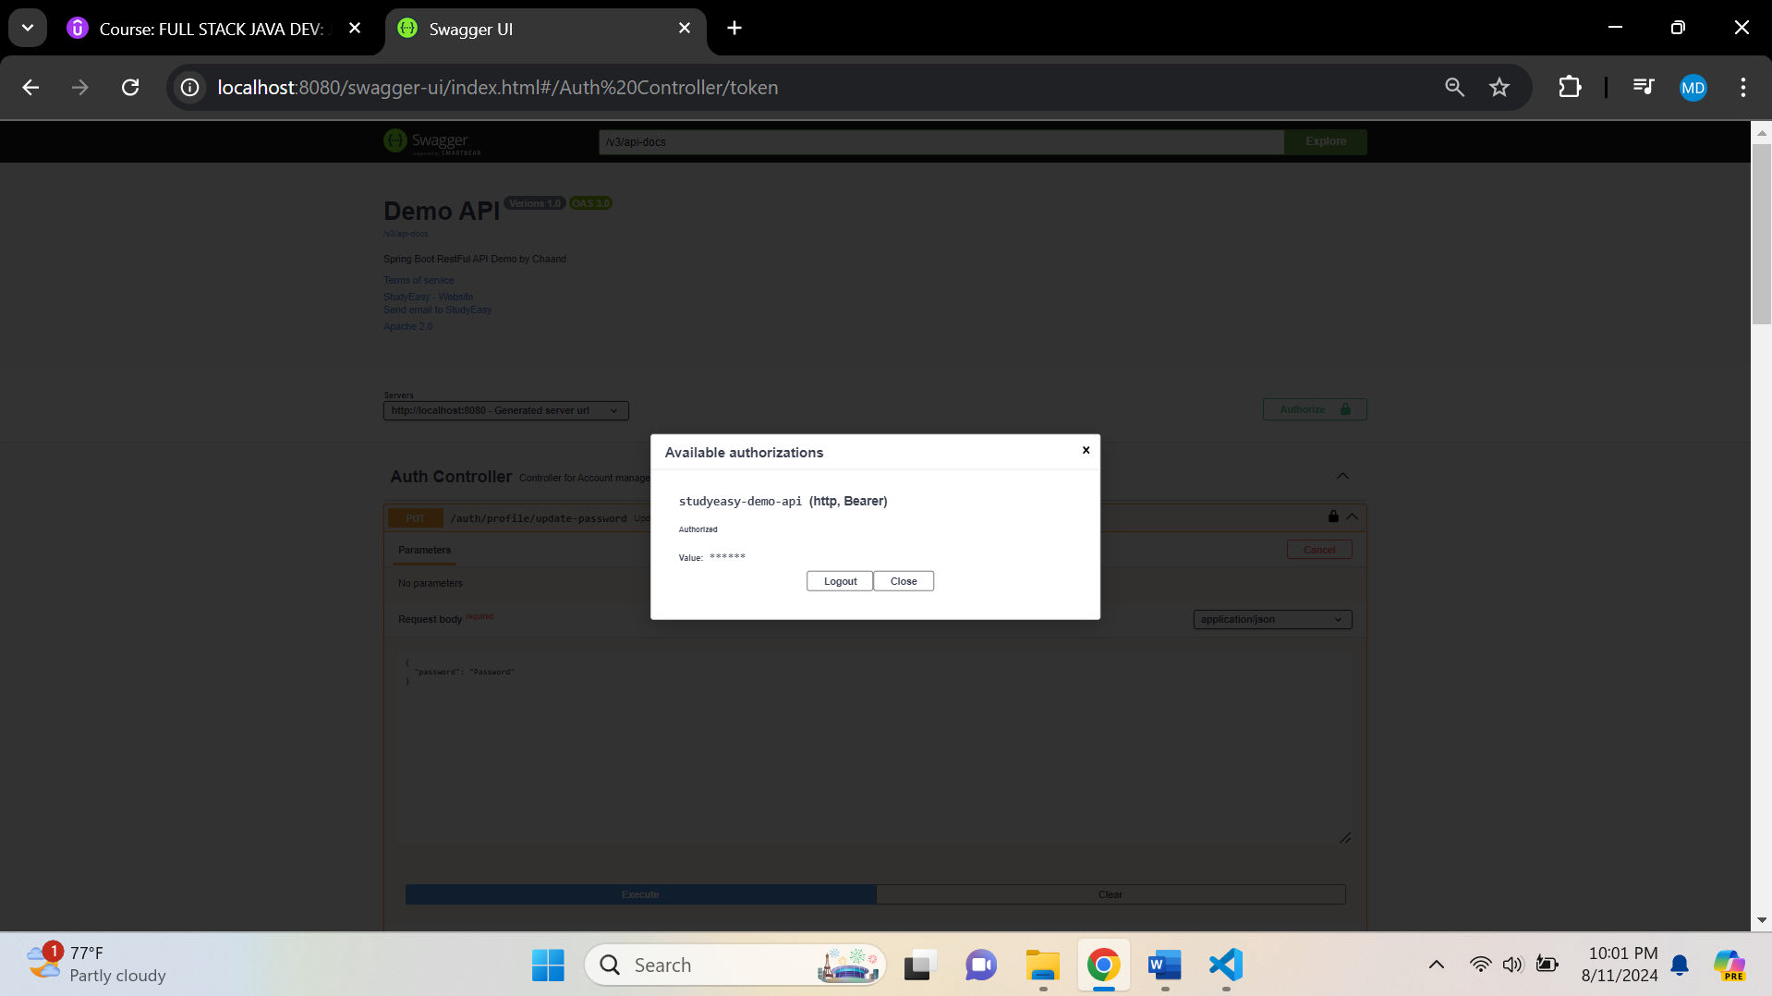

**You get error**

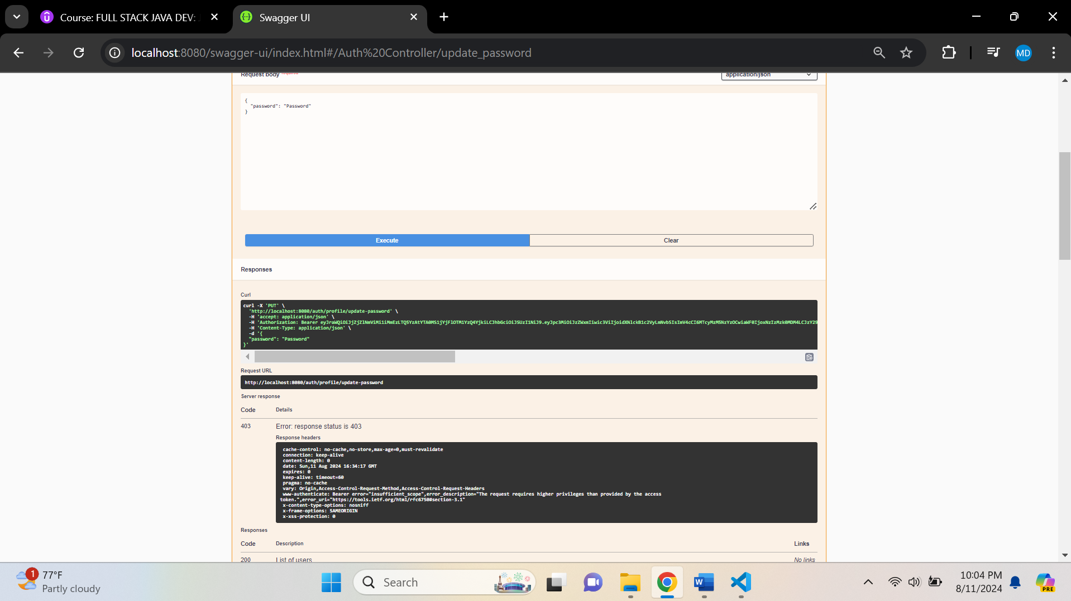

**In SecurityConfig.java -> add below line -> to give access**

.requestMatchers("/auth/profile/update-password").authenticated()

**Updated PasswordDTO.java – Remove to AllArgsConstructor()**

package org.studyeasy.SpringRestdemo.payload.auth;

import io.swagger.v3.oas.annotations.media.Schema;

import io.swagger.v3.oas.annotations.media.Schema.RequiredMode;

import jakarta.validation.constraints.Size;

import lombok.Getter;

import lombok.Setter;

@Getter

@Setter

public class PasswordDTO {

    @Size(min = 6, max = 20)

    @Schema(description = "Password", example = "Password", requiredMode = RequiredMode.REQUIRED, maxLength = 20, minLength = 6)

    private String password;

}

**Try to use old password and generate a token, it displays like below output**

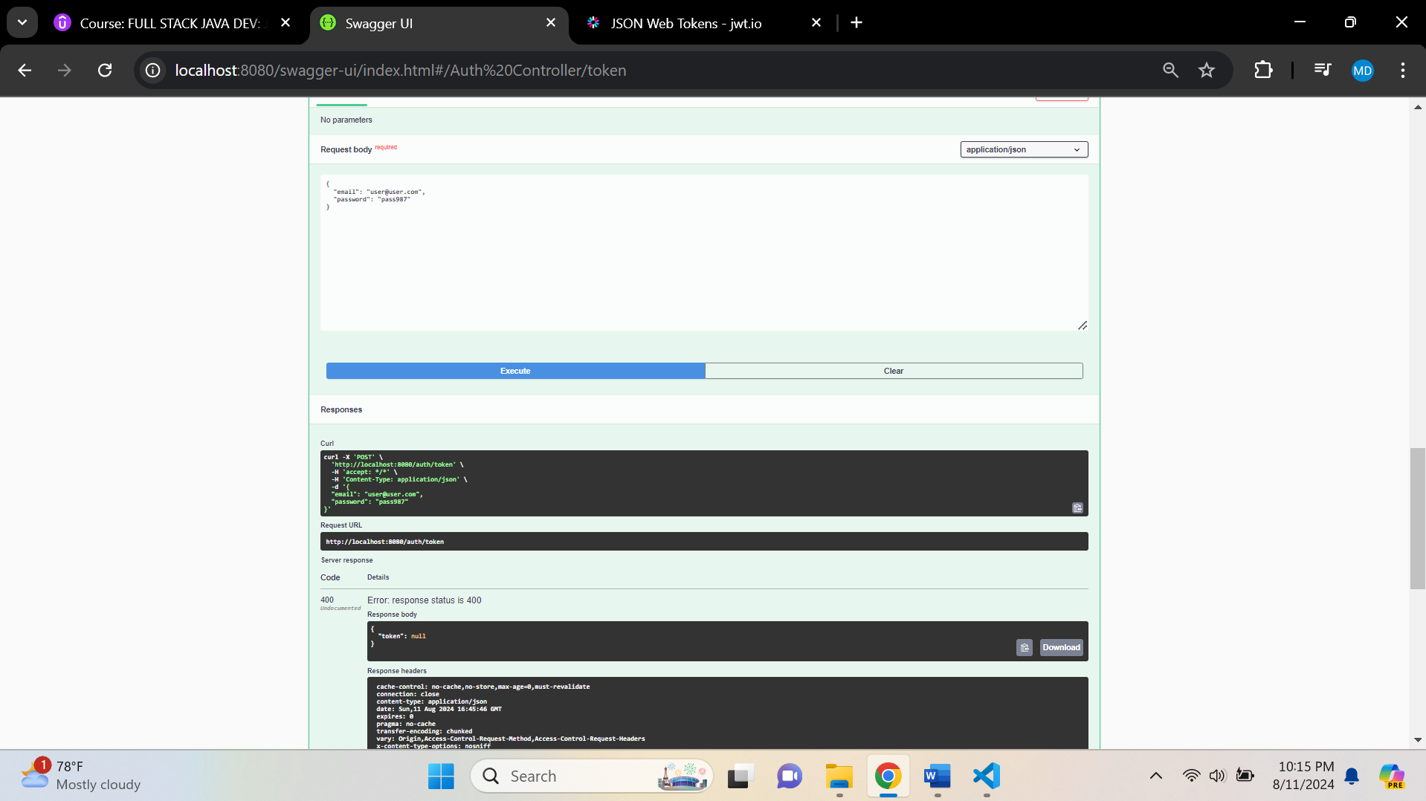

**Try to use new password and generate a token, it displays like below output**

